Flowchart of EEO Complaint Process
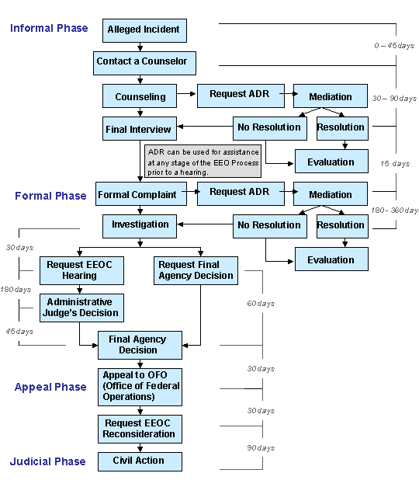

OFFICIALS AUTHORIZED TO RECEIVE EEO COMPLAINTS

EEO Officer BGen Julie L. Nethercot (843) 228-2535
Deputy EEO Officer Ms. Cynthia A. Golson (843) 228-2647
EEO Counselor Mrs. Tamara McMillan (843) 228-4919

